**Assignment # 3**

This assignment # 3 pertains to the requirement analysis and usability phases of your project.

For the project that you have selected in earlier phase, you are required to do

**Phase 3: Requirement Analysis**

1. **Define all the functional and non-functional requirements of your project.**

Functional:

a. The System will generate bills.

b. The System will able to store products in its database.

c. The System will able to print bill.

d. The System will able to generate sales reports.

e. The System will also print the sales reports.

f. User can create account and deposit money via bank transactions into his/her account.

g. User can explore all the bakery items.

Non-Functional:

a. The bill is generated by taking product name by using search bar, quantity of product and store it in its database.

b. The products is stored in the database so that the user can easily see its product list.

c. After the bill is prepared the print button will print the bill on thermal printer.

d. The User is able to see the sales report in the report section which include daily, monthly & total report.

e. The user can also export these reports in the excel reports.

1. **Develop complete use case diagram and define use cases with narratives.**

Use-case diagram:

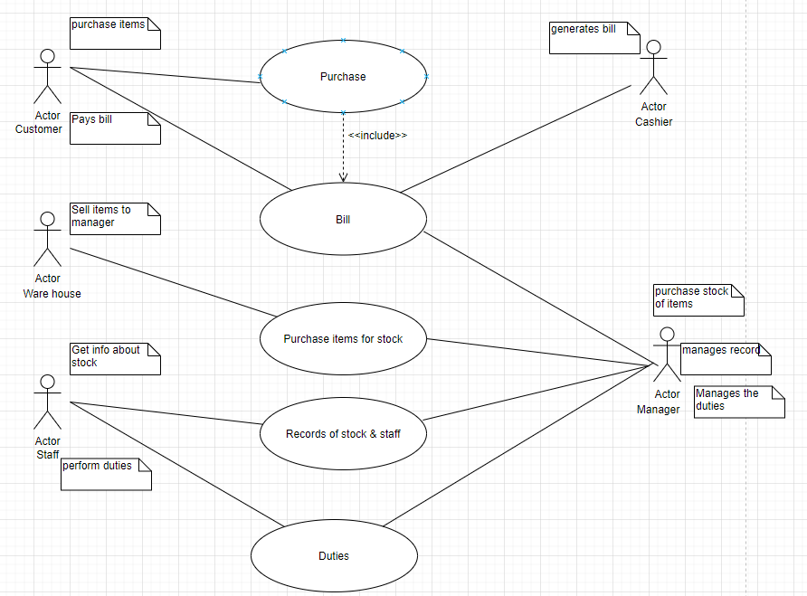

The Narratives:

|  |  |  |
| --- | --- | --- |
| Use Case Name: | Purchase | |
| ID: | UC-LHD-01 | |
| Actors Involved: | Customer | |
| Brief Description | Customer explore item and do purchase the items from whatever available at store. | |
| Pre-Conditions | Customer purchase item. | |
| Post-Conditions | After purchase get bill. | |
| Normal Flow of Events: | Actor Action | System Response |
| 1. Actor explore item.  2. Actor order item. | 1. System displays the item.  2. System displays cart. |

|  |  |  |
| --- | --- | --- |
| Use Case Name: | Bill | |
| ID: | UC-LHD-02 | |
| Actors Involved: | Customer, Cashier, Manager | |
| Brief Description | Customer pay the bill of purchased item, Cashier will generate the bill, and manager will record copies of bills. | |
| Pre-Conditions | Customer pay bill. | |
| Post-Conditions | Cashier generate bill & Manager record copies of bill. | |
| Normal Flow of Events: | Actor Action | System Response |
| 1. Actor pay bill.  2. Actor took bill with items. | 1. System generate bill.  2. System maintain the copy of bills. |

|  |  |  |
| --- | --- | --- |
| Use Case Name: | Purchase Item For Stock. | |
| ID: | UC-LHD-03 | |
| Actors Involved: | Warehouse, Manager | |
| Brief Description | Warehouse provide item for stock & Manager purchase those items for stock. | |
| Pre-Conditions | Warehouse runner sell the items. | |
| Post-Conditions | Manager purchase the item. | |
| Normal Flow of Events: | Actor Action | System Response |
| 1. Actor sell the item.  2. Actor purchase the item. | 1. System shows needed items.  2. System check items are correct. |

|  |  |  |
| --- | --- | --- |
| Use Case Name: | Records of Stock & Staff. | |
| ID: | UC-LHD-04 | |
| Actors Involved: | Staff, Manager | |
| Brief Description | Staff gets the information of items in stock & Manager will manage the records of those items. | |
| Pre-Conditions | Staff gets the information about stock. | |
| Post-Conditions | Manager will manage records | |
| Normal Flow of Events: | Actor Action | System Response |
| 1. Actor get info about stock.  2. Actor manage the record. | 1. System give info about stock.  2. System store the record. |

|  |  |  |
| --- | --- | --- |
| Use Case Name: | Duties | |
| ID: | UC-LHD-05 | |
| Actors Involved: | Staff, Manager | |
| Brief Description | Staff perform duties & Manager will provide the duties to staff and also manage the duties. | |
| Pre-Conditions | Staff perform duties. | |
| Post-Conditions | Manager manage duties. | |
| Normal Flow of Events: | Actor Action | System Response |
| 1.Actor perform duties.  2. Actor manage duties. | 1. System manage record of duties.  2. System manage staff presence. |

1. **Finally, you need to develop an ERD/data flow or sequence diagram, whichever suits your project.**

PS: All database projects should opt for and develop ERD diagram.

ERD:

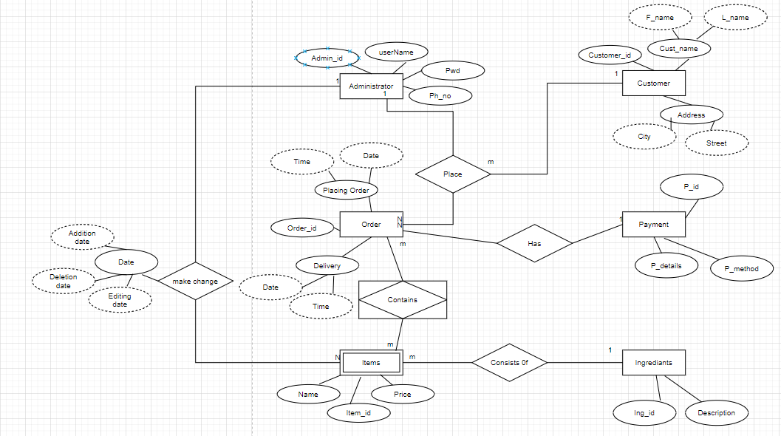

**Phase 4: Usability**

1. **Design the user interface using paper prototype and wireframes for your project. Follow all the rules that are discussed in the lecture.**

